Project Design Phase-II
Data Flow Diagram & User Stories

Date | May to June 2025
Team ID | LTVIP2025TMID57463
Project Name | BookNest: Where Stories Nestle
Maximum Marks | 4 Marks

Data Flow Diagrams:
A Data Flow Diagram (DFD) is a traditional visual representation of the information flows within a system. A neat and clear DFD can depict the right amount of the system requirement graphically. It shows how data enters and leaves the system, what changes the information, and where data is stored.
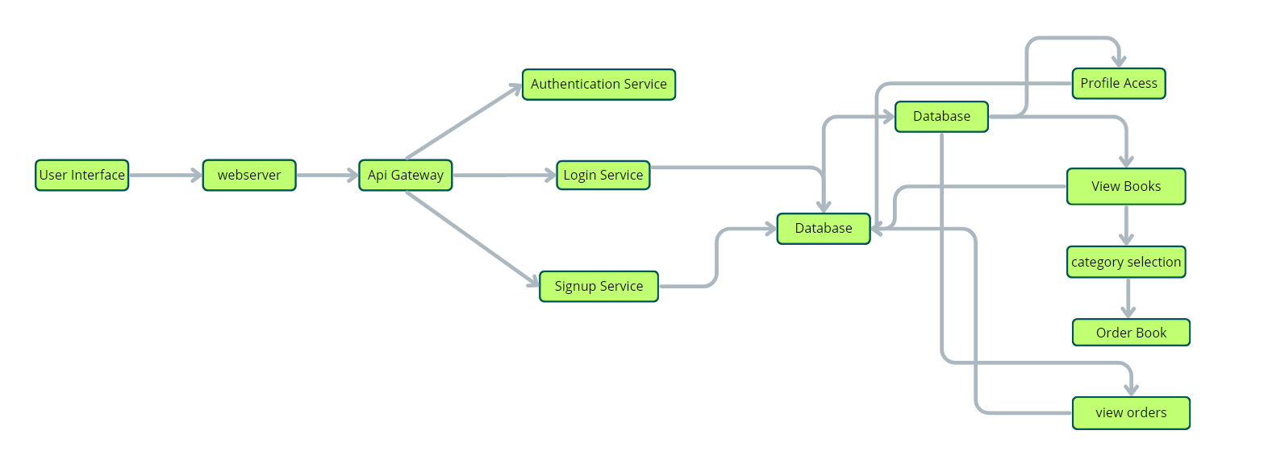
User Stories
Use the below template to list all the user stories for the product.
User Type | Functional Requirement (Epic) | User Story Number | User Story / Task | Acceptance Criteria | Priority | Release
Customer (Web) | Registration | USN-1 | As a user, I can register by entering email, password, and confirming password. | I can log in and access my dashboard | High | Sprint-1
Customer (Web) | Registration Confirmation | USN-2 | As a user, I receive a confirmation email after registration. | I receive and click the email link to activate my account | High | Sprint-1
Customer (Web) | Social Login | USN-3 | As a user, I can register using LinkedIn or Gmail. | I can register and log in using my Gmail account | Medium | Sprint-2
Customer (Web) | Login | USN-4 | As a user, I can log in using email and password. | I enter valid credentials and access the dashboard | High | Sprint-1
Customer (Web) | Browse Books | USN-5 | As a user, I can browse books by genre, title, or author. | I see a list of matching books with filters and sorting | High | Sprint-2
Customer (Web) | Place Orders | USN-6 | As a user, I can add books to my cart and place an order. | I get order confirmation after successful checkout | High | Sprint-2
Customer (Web) | Feedback | USN-7 | As a user, I can leave feedback for a book I purchased. | Feedback is submitted and shown to seller/admin | Medium | Sprint-3
Seller | Book Listing | USN-8 | As a seller, I can add new books with details. | Book appears in the catalog after submission | High | Sprint-1
Seller | Inventory Management | USN-9 | As a seller, I can view and manage stock of books listed. | Stock can be updated and reflected in book detail page | High | Sprint-2
Seller | Order Fulfillment | USN-10 | As a seller, I can view incoming orders and mark them as fulfilled. | Order status updates after action | High | Sprint-3

